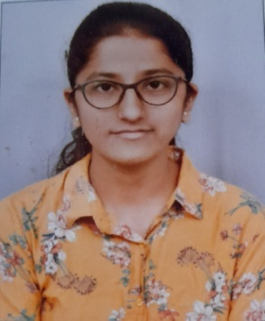

Manisha M Hatalageri

**Mobile No**: +91-9482467617

**Email ID:** manishahatalageri@gmail.com

# CAREER OBJECTIVE

To get a job in good and creative environment where I can enrich and utilize my skills and knowledge for the growth of the company.

# ACADEMICS

|  |  |  |  |  |
| --- | --- | --- | --- | --- |
| **Course** | **Name of the institute** | **Board/University** | **Year of passing** | **Percentage/CGPA** |
| B.E | KLE Technological University, Hubballi | KLE Technological University, Hubballi | Pursuing | 8.46(CGPA till 6th semester) |
| P.U.C | Vidya. P. Hanchinmani PU Science College, Dharwad | Department of Pre University, Govt. of Karnataka | 2019 | 80% |
| S.S.L.C | Mayur English medium School, Gokak | Karnataka Board | 2017 | 94.40% |

# PERSONAL DETAILS

**Date of birth:** 5th January, 2001

**Father’s name:** Mallappa Hatalageri

**Mother’s name:** Jayashree Hatalageri

**Permanent address:** Drivers’ colony, Gandhinagar, Dharwad

**Interests:** Drawing, painting, listening to music

**Languages known:** English, Kannada and Hindi

**Skills in programming languages:** C language

**PROJECTS**

**Mini project:**

* Conducted a survey on the proposed layout.
* Designed Sewage Treatment Plant.

**Minor project:**

* Proposed a plan for commercial building in AutoCAD software.
* Designed structural members(slabs, beams, columns) and calculated overall load using SAP software.
* Analysed Earned Value Analysis using Primavera software

**CERTIFICATIONS**

* Feb 2022 Coursera(Work Smarter with Microsoft Excel)
* May 2020 Coursera(Autodesk Certified Professional: AutoCAD for Design and Drafting Exam Prep)